Marlborough Primary School
Board of Trustees 2016-2019

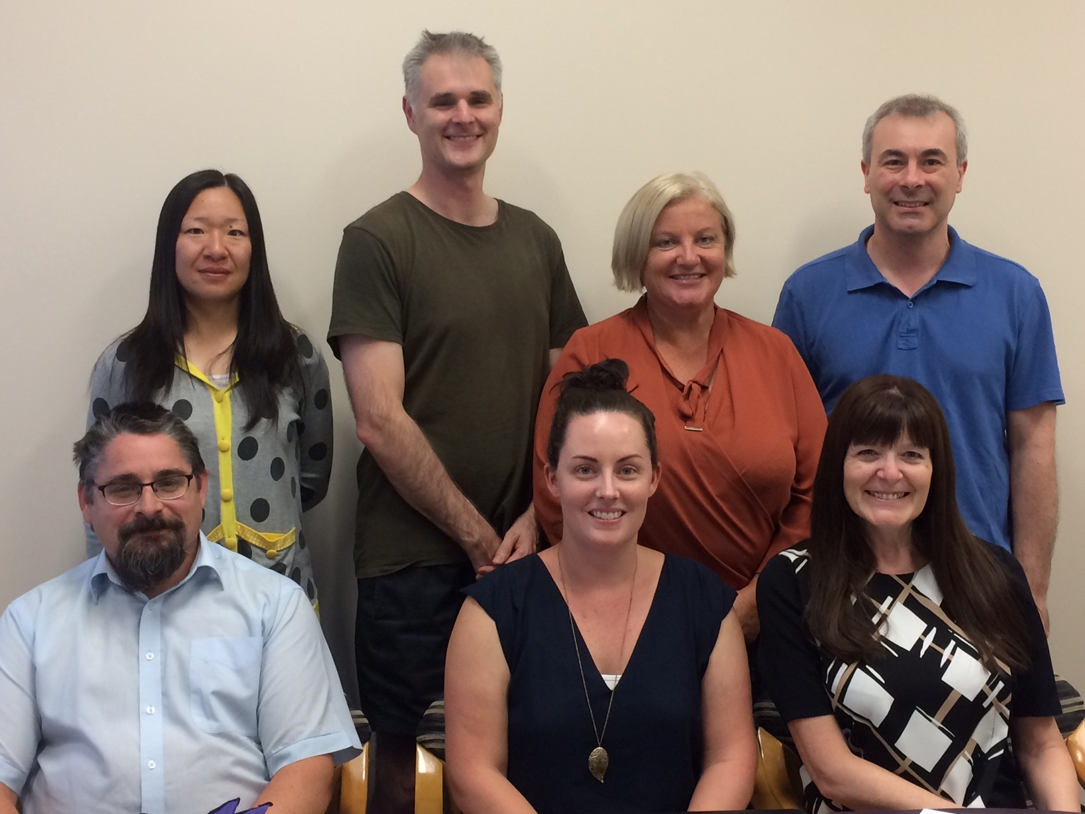
Back row:
Maggie Hu, Matthew Carroll, Cherie Holland, Andrew Dickson
Front row:
Anthony Wrigley (Chairperson), Ria Henty, Sue Buckley (Principal)

Maggie Hu
I was elected as parent trustee from 2016, and it is such a privilege to serve the school community and to provide the best for our children. With my previous management experiences in after school programmes, I am deeply impressed by our efficient school management team, devoted teachers and amazing school community. We are so happy that my son Felix gets to attend such a great school.

Tony Wrigley
I am the New Zealand Operations Manager for Cloud Services @ Datacom.
I have been on the Board of Trustees for 5 Years and Chair of the Board of Trustees for the last 2 years.
Currently I am an active member of Scouting New Zealand, as a leader as well as playing senior hockey at North Harbour.

Ria Henty BEd
Staff Representative since 2016.
I have been teaching at Marlborough Primary for 5 years and am currently in Room 8 teaching Year 1 children. My role as Staff Representative is to report the views of the staff to the Board as well as reporting Board decisions and policy changes to the staff.
Marlborough is a fabulous school, which not only produces fabulous academic results but provides a safe, caring, fun, approachable and nurturing environment for our tamariki to learn and play.
I am fortunate to be a part of an amazing and supportive team of staff, teachers and children who allow me to love my job.

Matthew Carroll
Matthew has served as an elected BOT member since 2013. He was Board Chair from 2013-2015.
Professionally Matthew has 20 years’ experience in the profession of podiatry and was Head of
Podiatry at Auckland University from 2009-2018. He is currently Head of Postgraduate
Programmes within the School of Clinical Sciences at Auckland University of Technology. Matthew
is Deputy Chair of the Podiatrists Board of New Zealand and Director/Treasurer of the Australia
New Zealand Podiatric Accreditation Council (ANZPAC).

Cherie Holland
Cherie is a mum of two beautiful children who both attend Marlborough Primary. She has up to recently been the Chairperson of the Friends of the School committee however has resigned so she can concentrate on her Board duties and how best to assist the school. Cherie is a busy lawyer and loves spending time with her family. Marlborough Primary’s community is very important to Cherie who was Chairperson of the Birkenhead Plunket committee and Marlborough Kindergarten committee. Her hobbies (when she gets time to do them) are anything craft related, in particular, building period miniature 1/2 scale houses and furniture.

